**DERIVATIVES**

**E**

**C**

**O**

**N**

**F**

**-**

**3**

**5**

**4**

**& RISK**

**MANAGEMENT ASSIGNMENT**

Mihir Raman

-2022A4

PS1300H

Ananya Sri TK

* 2022A4PS0944H

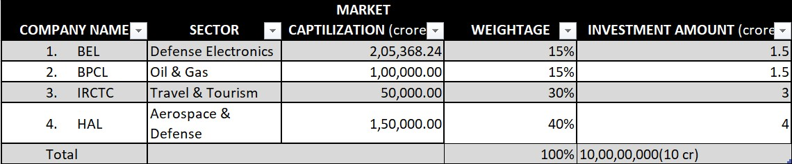

**1**

**PART**

Portfolio Overview

**1**

**PART**

**Portfolio Descri**

**p**

**tion**

**Portfolio Value**

**:**

**₹10 crore, strategically allocated across four leading companies: BEL,**

**BPCL, IRCTC, and HAL.**

**Sectoral Re**

**p**

**resentation**

**:**

HAL (40%): Dominates the portfolio with its strong foothold in the aerospace and defense sector, benefiting from

government initiatives and growing global demand.

1

.

IRCTC (30%): Capitalizes on the booming travel and tourism industry, leveraging its monopoly in Indian railway catering

and ticketing services.

2

.

BEL (15%): A leader in defense electronics, providing stability through its consistent performance and robust market

capitalization.

3

.

BPCL (15%): Represents the oil and gas sector, offering moderate returns amidst energy market fluctuations.

4

.

Diversification: The portfolio balances high-growth potential in defense and travel sectors with stability in electronics and energy.

5

.

**Part 1 RETURNS**

**Link to Excel Sheet Containing all the returns with the Graphs** :[https://hyderabadbitspilaniacin0my.sharepoint.com/:x:/r/personal/f20221300_hyderabad_bits-pilani_ac_in/_layouts/15/Doc.aspx?](https://hyderabadbitspilaniacin0-my.sharepoint.com/:x:/r/personal/f20221300_hyderabad_bits-pilani_ac_in/_layouts/15/Doc.aspx?sourcedoc=%7B33E5CFB0-49F2-4F89-A04C-36907C80F885%7D&file=Part-1%20Sheet%20of%20All%20Returns%20Along%20with%20the%20Graphs.xlsx&action=default&mobileredirect=true)

[sourcedoc=%7B33E5CFB0-49F2-4F89-A04C-36907C80F885%7D&file=Part-](https://hyderabadbitspilaniacin0-my.sharepoint.com/:x:/r/personal/f20221300_hyderabad_bits-pilani_ac_in/_layouts/15/Doc.aspx?sourcedoc=%7B33E5CFB0-49F2-4F89-A04C-36907C80F885%7D&file=Part-1%20Sheet%20of%20All%20Returns%20Along%20with%20the%20Graphs.xlsx&action=default&mobileredirect=true)

[1%20Sheet%20of%20All%20Returns%20Along%20with%20the%20Graphs.xlsx&action=default&mobileredi rect=true](https://hyderabadbitspilaniacin0-my.sharepoint.com/:x:/r/personal/f20221300_hyderabad_bits-pilani_ac_in/_layouts/15/Doc.aspx?sourcedoc=%7B33E5CFB0-49F2-4F89-A04C-36907C80F885%7D&file=Part-1%20Sheet%20of%20All%20Returns%20Along%20with%20the%20Graphs.xlsx&action=default&mobileredirect=true)

**Link to the Code for Calculating Daily Returns & Correlation Plots**  :

https://colab.research.google.com/drive/1rXtD0DIrL2kHvTGOF0JGJbxATKBr1jhe

**NOTE :** The Excel Sheet above must be uploaded to the Google Colab Environment and the path must be reset to run both the codes.

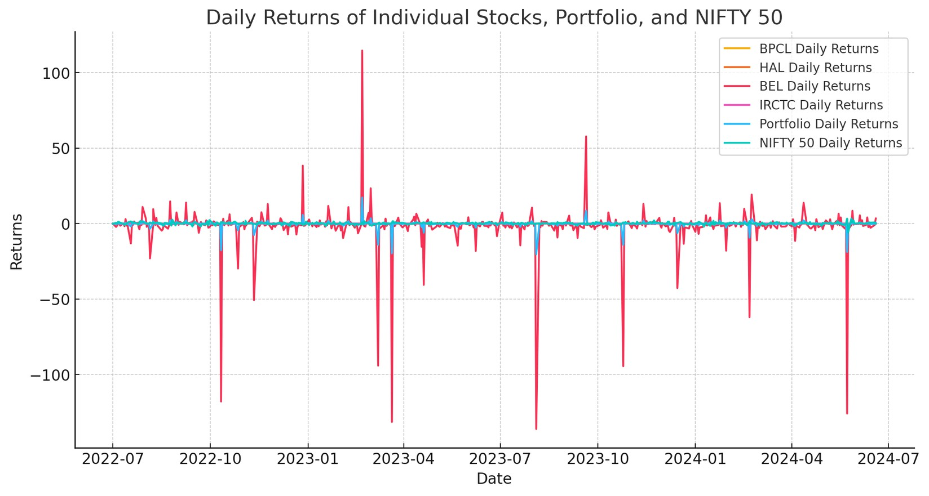

**1**

**PART**

Gra

phs of Dail

y

Returns

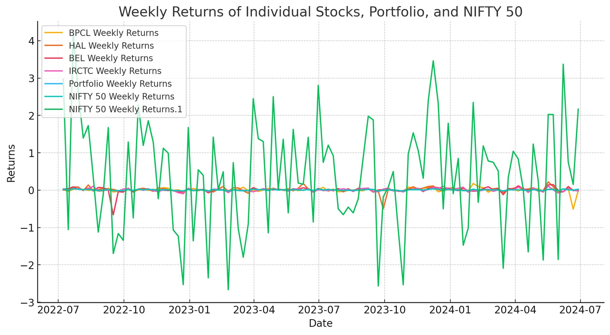

**1**

**PART**

Gra

phs of Weekl

y

Returns

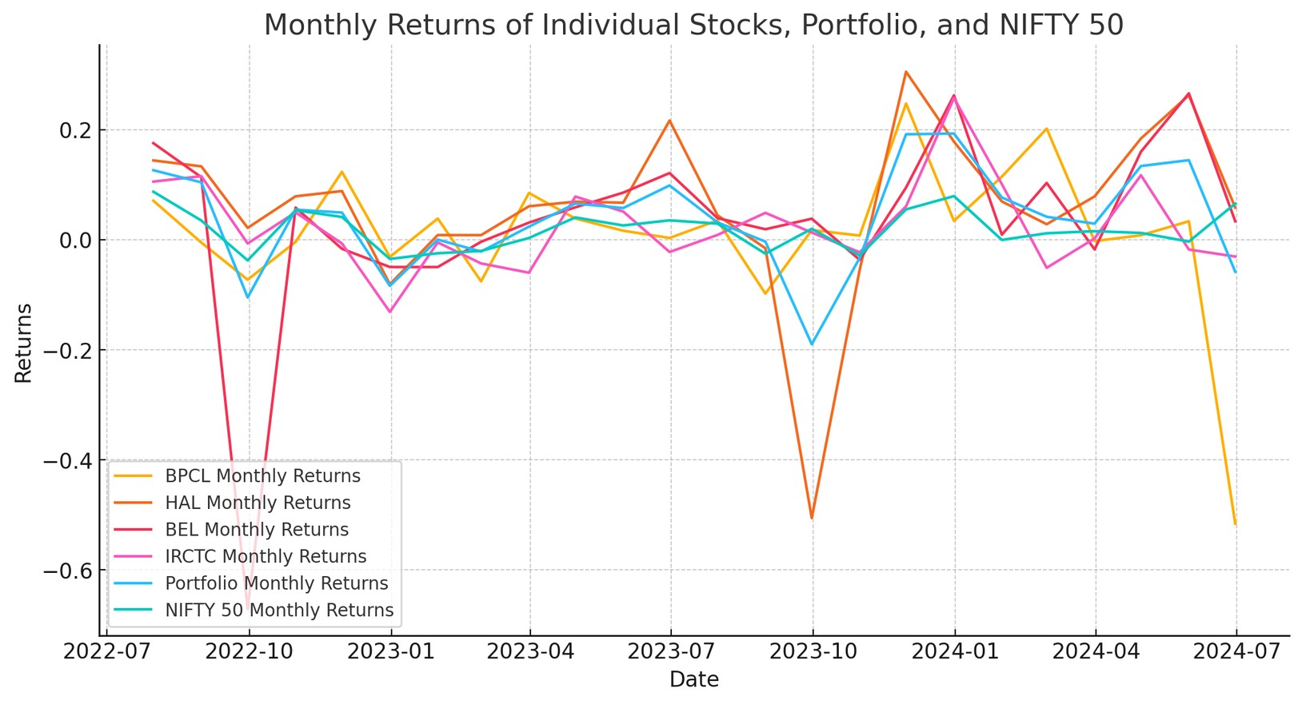

**1**

**PART**

Gra

phs of Monthl

y

Returns

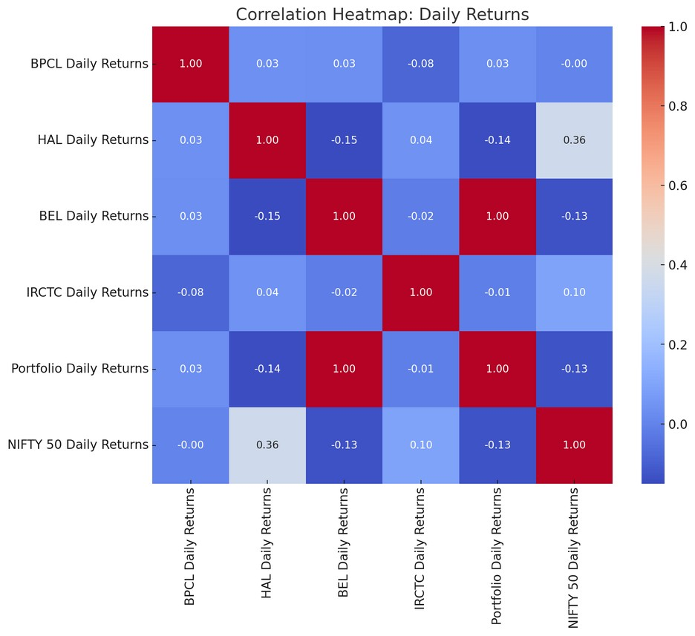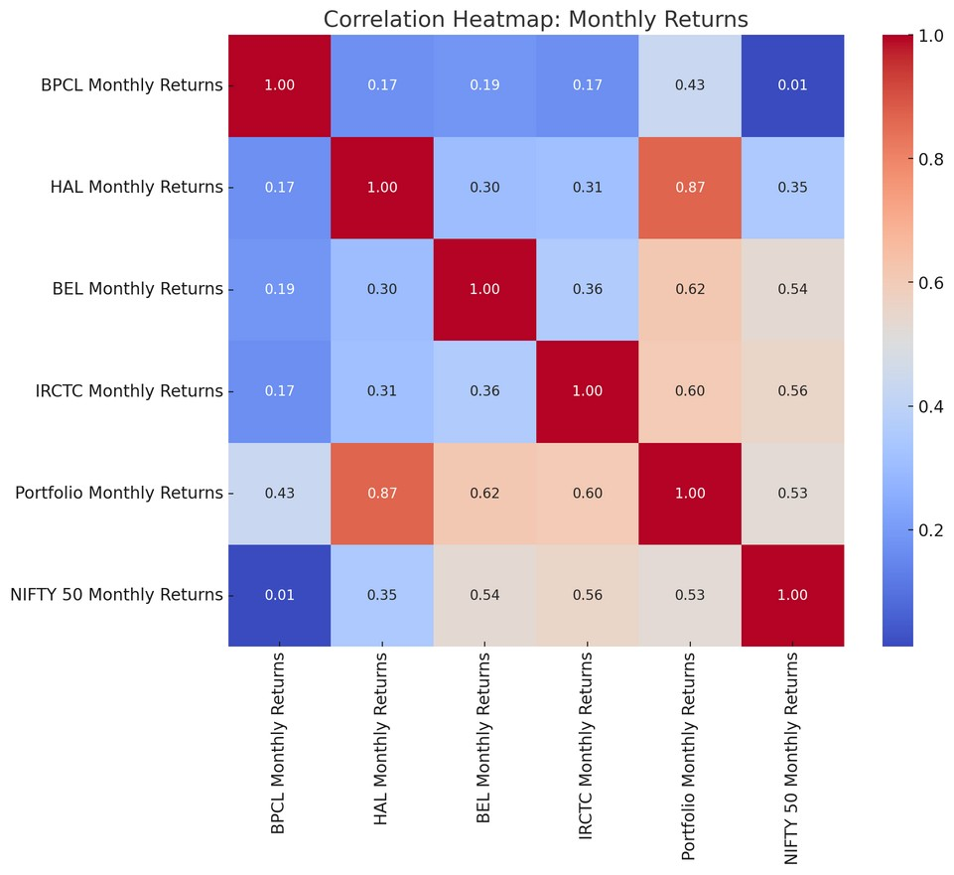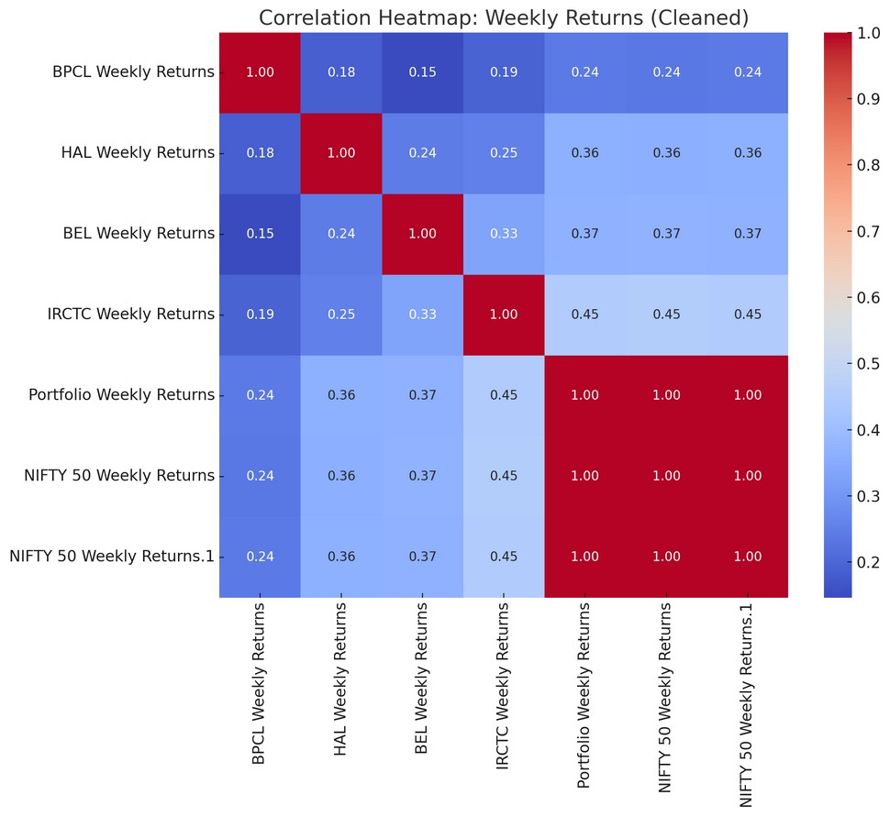

**1**

**PART**

Correlation Heat Ma

ps

**1**

**PART**

**Correlation Heat Ma**

**p**

**s**

Conclusion

Time Horizon Effect:

1

.

Longer horizons reveal stronger correlations due to noise reduction and the dominance of sustained

trends.

Portfolio Alignment with NIFTY 50:

2

.

The portfolio maintains a consistently positive correlation with the NIFTY 50 index.

The correlation strengthens progressively from daily to monthly horizons.

Patterns by Time Horizon:

3

.

Daily: Moderate positive correlation with occasional neutral/weak signals.

Weekly: Strong positive correlation as sectoral trends dominate.

Monthly: Very strong correlation driven by broader market alignment.

# PART2

To hedge the portfolio comprising BPCL, BEL, IRCTC, and HAL, we will use their respective stock futures contracts. These futures are ideal because they are directly linked to the underlying stocks, allowing precise risk management for each position in the portfolio.

1.**BPCL Stock Futures**: This contract will hedge the BPCL stock position, effectively offsetting price fluctuations in the underlying stock. The BPCL futures have a standard lot size of 25 and are settled based on the closing price of BPCL on the last trading day of the month.

2.**BEL Stock Futures**: BEL stock futures will be used to manage the price risk associated with BEL shares. These futures provide a direct correlation to BEL stock price movements, ensuring efficient hedging.

3.**IRCTC Stock Futures**: IRCTC futures will hedge the IRCTC stock position. With a lot size of 25, this contract minimizes deviations between the hedged and actual value of the underlying stock position.

4.**HAL Stock Futures**: HAL stock futures will manage the price risk of HAL shares. Like the others, these futures are aligned with HAL’s price fluctuations, providing an effective hedge.

## Part 2

**Link to the Combined Sheet of All the Futures Data :** https://hyderabadbitspilaniacin0my.sharepoint.com/:x:/g/personal/f20221300_hyderabad_bitspilani_ac_in/Ecx6odtwBz9DrENOtkcAdMcB5ca_P4BdwoFWI5dSh40DAQ?e=ltgE1s

**Link to Excel Sheet Containing all the returns with the Graphs** : [https://hyderabadbitspilaniacin0my.sharepoint.com/:x:/r/personal/f20221300_hyderabad_bits-pilani_ac_in/_layouts/15/Doc.aspx? sourcedoc=%7B33E5CFB0-49F2-4F89-A04C-36907C80F885%7D&file=Part-](https://hyderabadbitspilaniacin0-my.sharepoint.com/:x:/r/personal/f20221300_hyderabad_bits-pilani_ac_in/_layouts/15/Doc.aspx?sourcedoc=%7B33E5CFB0-49F2-4F89-A04C-36907C80F885%7D&file=Part-1%20Sheet%20of%20All%20Returns%20Along%20with%20the%20Graphs.xlsx&action=default&mobileredirect=true)

[1%20Sheet%20of%20All%20Returns%20Along%20with%20the%20Graphs.xlsx&action=default&mobileredirect=true](https://hyderabadbitspilaniacin0-my.sharepoint.com/:x:/r/personal/f20221300_hyderabad_bits-pilani_ac_in/_layouts/15/Doc.aspx?sourcedoc=%7B33E5CFB0-49F2-4F89-A04C-36907C80F885%7D&file=Part-1%20Sheet%20of%20All%20Returns%20Along%20with%20the%20Graphs.xlsx&action=default&mobileredirect=true)

**Link to Nifty 50 returns** : https://hyderabadbitspilaniacin0my.sharepoint.com/:x:/g/personal/f20221300_hyderabad_bitspilani_ac_in/EXw4z5TQKc1OhELB0zVLZakBhLwRJN50fdS21f4thbngHQ?e=IxGhqs

**Link to Code for calculating Nift returns, variance and covariance OHR and Optimal Number of Contracts for different durations**

: https://colab.research.google.com/drive/1z_co5x3bR_zGQZE2ys7HBuj2UCjBTVIN#scrollTo=VOvg6_gSjwqA

## Part 2

**Note :**

**The files in the followingfolder must be uploaded to the google colab environment to run the code. https://hyderabadbitspilaniacin0-my.sharepoint.com/:f:/g/personal/f20221300_hyderabad_bitspilani_ac_in/EglcazKX4_JEv-sjxLvuoaAB9JJi1VWqzwYqBu5g9Jq3vQ?e=3AaF66**

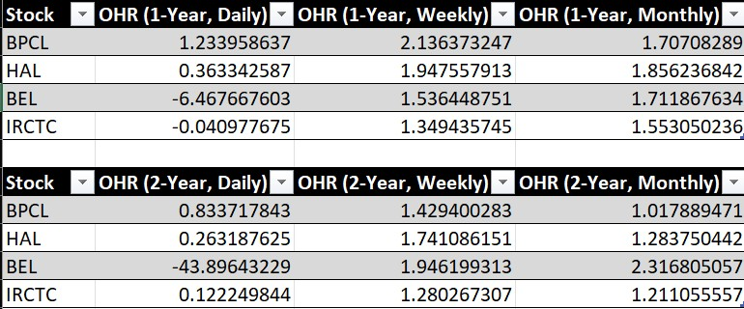

**PART**

**2**

OHR

### PART2 Optimal Number of Contracts

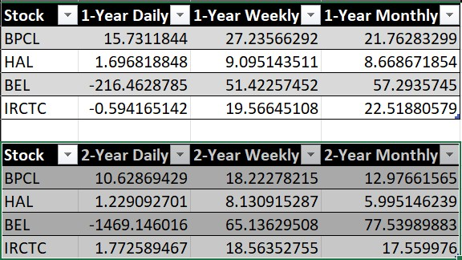

## Part 2

**Note :**

**The files in the followingfolder must be uploaded to the google colab environment to run the code. https://hyderabadbitspilaniacin0-my.sharepoint.com/:f:/g/personal/f20221300_hyderabad_bitspilani_ac_in/EglcazKX4_JEv-sjxLvuoaAB9JJi1VWqzwYqBu5g9Jq3vQ?e=3AaF66**

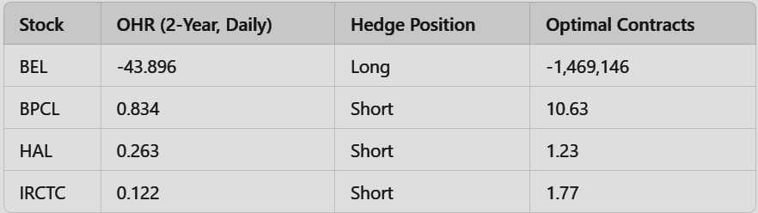

**PART**

**2**

# PART2

To hedge the portfolio, the positions and contracts were determined based on the 2-year daily Optimal Hedge Ratio (OHR). BEL required a long hedge with -1,469,146 futures contracts entered at ₹312.00 and closed at ₹309.95. BPCL used a short hedge with 10.63 contracts entered at ₹400.95 and exited at ₹394.50. HAL's short hedge involved 1.23 contracts, entered at ₹2,941.89 and exited at ₹2,891.50. IRCTC used a short hedge with 1.77 contracts, entered at ₹740.52 and exited at ₹728.40. These strategies mitigate portfolio risk during the reference period from July 1, 2024, to September 25, 2024.

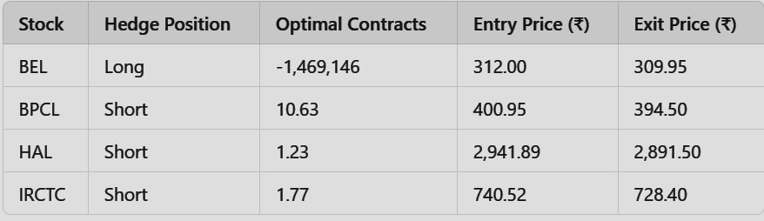

## Part 3

**Link to Code for Part 3** -

https://colab.research.google.com/drive/1Wadk5Ab73Ah1IO1fSdA484pgJaEycbU4#scrollTo=A1QnbtfBGbxL

**Note** : The following files must be uploaded to the Google Colab Environment to Run the Code https://hyderabadbitspilaniacin0-my.sharepoint.com/my?

id=%2Fpersonal%2Ff20221300%5Fhyderabad%5Fbits%2Dpilani%5Fac%5Fin%2FDocuments%2F1%2E%2 0BITS%2FClasswork%5FBITS%2FSemester%5F3%2D1%5FBITS%2FDRM%20Assignment%203%2D1%2FPa rt%2D3%5Fdata%5Fused

## PART3

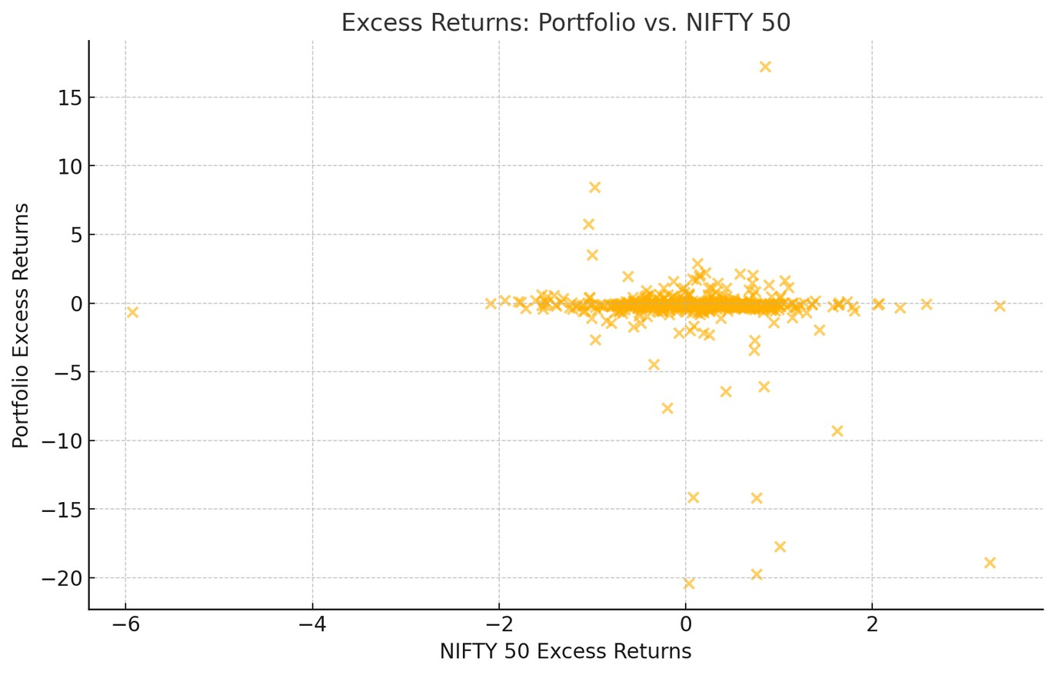

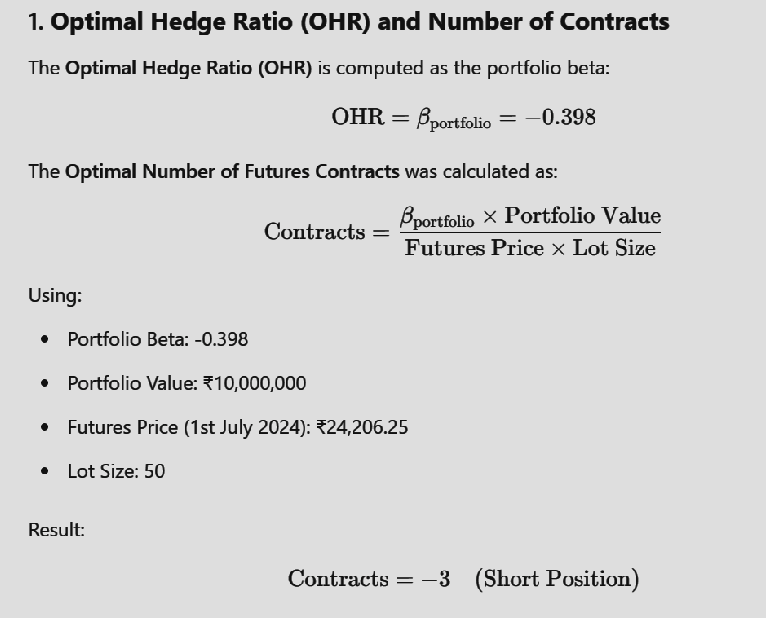

**PART**

**3**

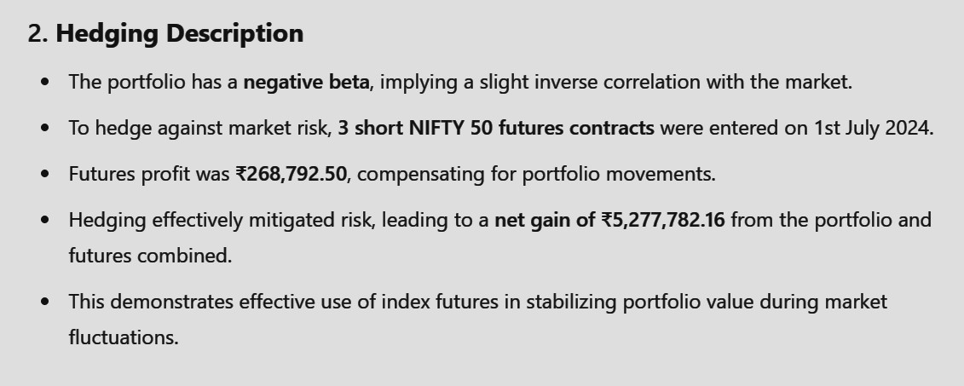

**PART**

**3**

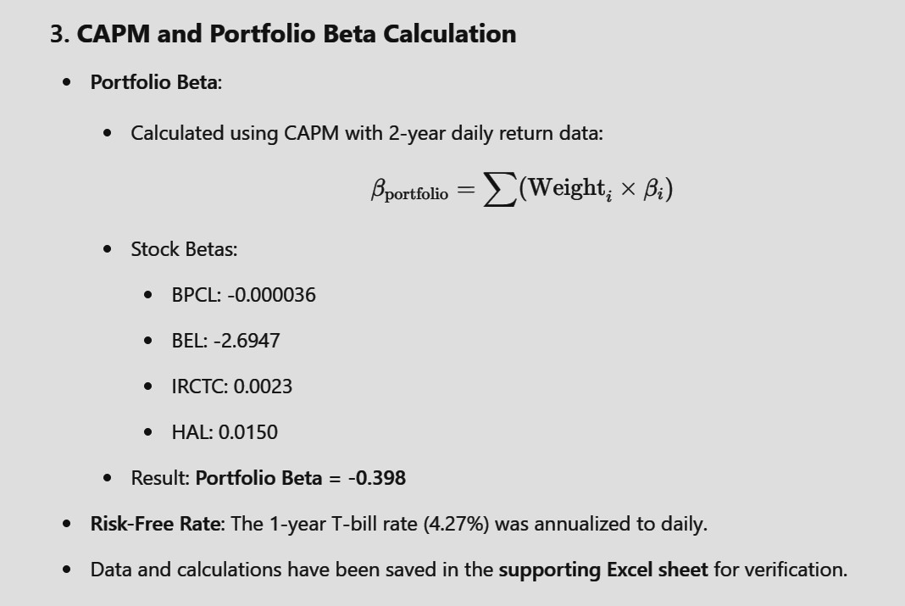

**PART**

**3**



**PART**

**3**

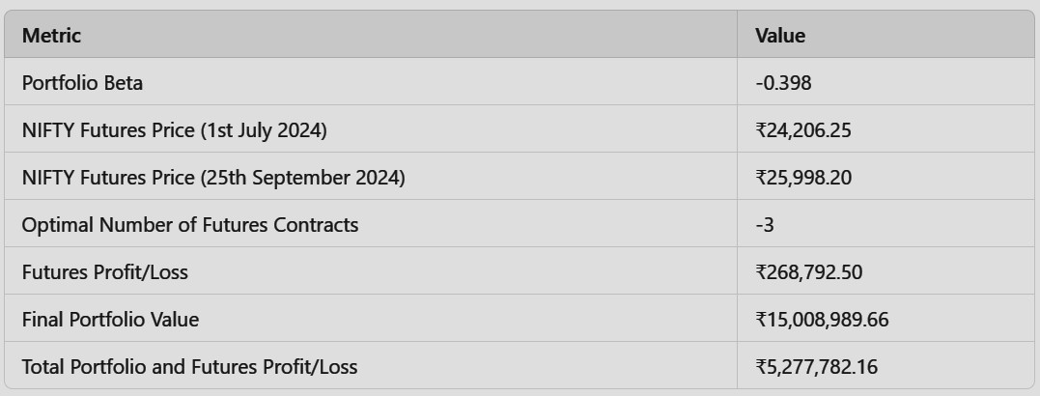

**PART**

**3**

## Part 4

Link to Code for Part 3 - https://colab.research.google.com/drive/1amFDHnIow_mzbeA1kqyfAo3VUprd5au#scrollTo=9e53E4Anosee

Note : The following files must be uploaded to the Google Colab Environment to Run the Code https://hyderabadbitspilaniacin0-my.sharepoint.com/:f:/g/personal/f20221300_hyderabad_bitspilani_ac_in/Eqpz681272xGrCMYvWNW3rMBGtW1QnbVrTnTbh1x1ukAIw?e=z2k2AQ

**Part 4** 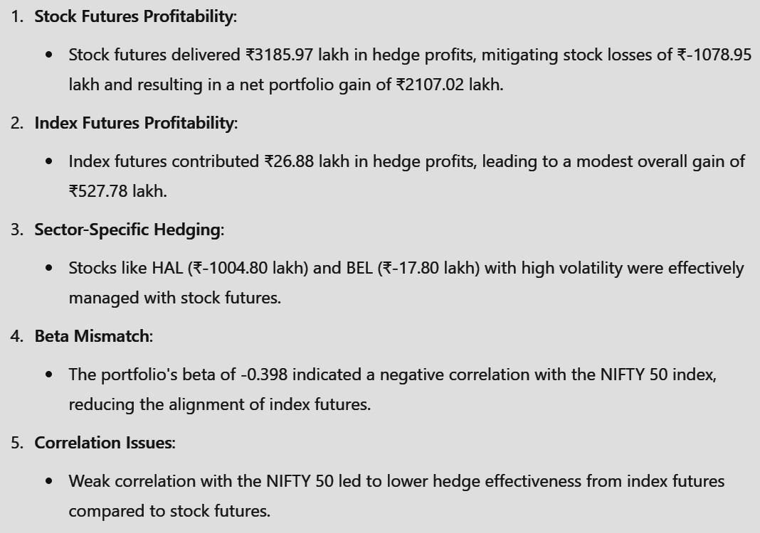

## Part 4

**4**

**PART**

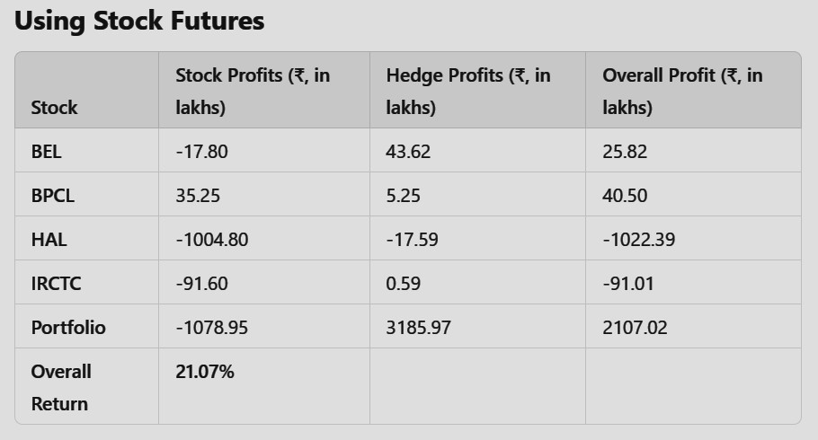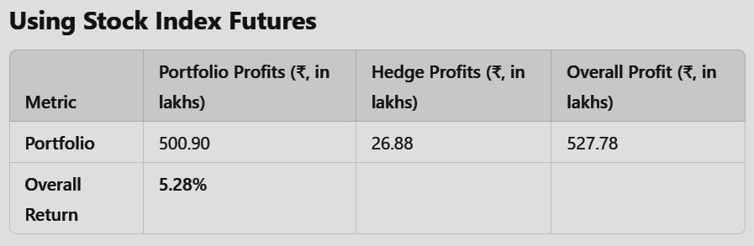

**4**

**PART**

**Link To All The Codes**

**Part 1** :

https://colab.research.google.com/drive/1rXtD0DIr L2kHvTGOF0JGJbxATKBr1jhe?usp=sharing

**Part 2** :

https://colab.research.google.com/drive/1z_co5x3 bR_zGQZE2ys7HBuj2UCjBTVIN?usp=sharing

**Part 3** :

https://colab.research.google.com/drive/1z_co5x3 bR_zGQZE2ys7HBuj2UCjBTVIN?usp=sharing

**Part 4** :

https://colab.research.google.com/drive/1amFDHn -Iow_mzbeA1kqyfAo3VUprd5au?usp=sharing

### Link of files to be uploaded in the Environment

**Part 1** : https://hyderabadbitspilaniacin0my.sharepoint.com/:f:/g/personal/f20221300_hyderabad_bitspilani_ac_in/Et5q_ZdP00lHqCcOdDeEoMgBQYZrQU0gJZVAq02iUGO

2Pg?e=FVKbpD

**Part 2** : https://hyderabadbitspilaniacin0my.sharepoint.com/:f:/g/personal/f20221300_hyderabad_bitspilani_ac_in/EglcazKX4_JEv-sjxLvuoaABiwQLc_QI6pOIUFuFgo1DKw? e=VzqJTk

**Part 3** : https://hyderabadbitspilaniacin0my.sharepoint.com/:f:/g/personal/f20221300_hyderabad_bitspilani_ac_in/EjDWCljox7VDuepZpnr7HjYBKZAnEqfsGUG7IDe-uTWTA?e=6cc90L

**Part 4** : https://hyderabadbitspilaniacin0my.sharepoint.com/:f:/g/personal/f20221300_hyderabad_bitspilani_ac_in/Eqpz681272xGrCMYvWNW3rMBFBZCXCcD0NqErMWuGZ

0MhA?e=AHzsgq

**Note : I have used codes to for this analysis**

# THANK YOU